Start
Start (Pre-A1)

A Funny Day At The Beach!
Look at the picture and read. Choose the correct answer for questions 1-12.
Jane, Lion and Lisa are enjoying the happy vacation with their parents.
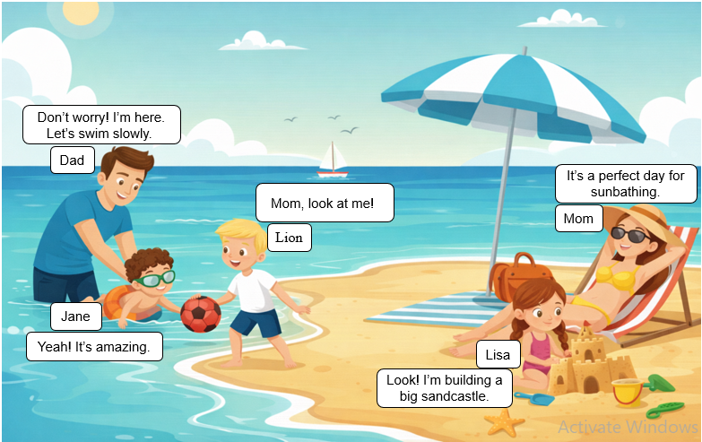
- The family is spending time at the ….
  - park B) beach C) school D) zoo
- How many people are there in the picture?
  - four B) five C) six D) seven

- What is the float used for?
  - swimming safely B) playing with ball C) sunbathing D) relax

- Where is the father?
  - on the sand B) in the sea C) on the lounger D) in the boat
Start

- Lion is playing with a ….
  - kite B) ball C) bucket D) float
Start

- Why is the umbrella on the beach?
  - to give shade B) to stop the rain C) to play games D) to swim

- What is the mother doing?
  - swimming B) reading C) sunbathing D) sleeping
Start

- What object helps the mother enjoy sunbathing?
  - a bucket B) a castle C) a lounger D) sand

- What object helps Lisa make a sandcastle on the beach?
  - beach spade B) suftboard C) tower D) life ring

- The father is helping Jane to ….
  - swim B) play football C) study math D) splash water
Start

- What can you see in the sea?
  - a car B) a boat C) a bike D) a dog

- Why does Jane wear goggles in the sea?
  - to see underwater B) to play with ball C) to make sand D) to keep warm

Look at the picture and read. Choose the correct answer for questions 13-25.
A family is enjoying time together outdoors.
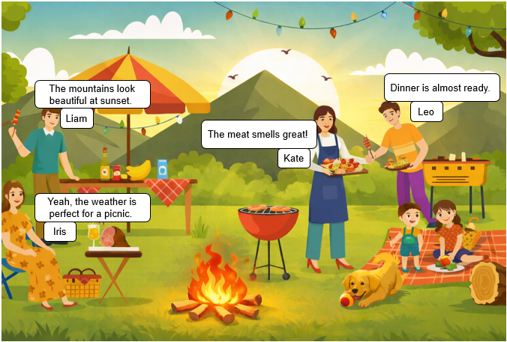
- What is the best title for this picture?
  - a rainy day B) a family picnic C) school life D) city life

- What can you infer about the children’s mood?
  - bored. B) angry. C) happy. D) afraid.

- What are the children sitting on?
  - a bed. B) a chair. C) a mat. D) grass.

- Which object is used to cook food in the picture?
  - stove. B) oven. C) grill. D) microwave.

- What can you see in the background of the picture?
  - buildings B) mountains C) beach D) school

- Which item is used to serve or hold food?
Start
  - a tray B) a book C) a backpack D) a ball

- The picnic mat has more than one color, so it looks ....
  - plain B) colorful C) empty D) broken

- The sunlight gives the scene a ... feeling.
  - cold B) warm C) scary D) noisy

- Kate is wearing an apron to keep her clothes ....
  - clean B) cold C) heavy D) old

- The picture shows a happy ....
  - money B) family C) rules D) work

- The weather in the picture looks ....
  - cold B) rainy C) sunny D) stormy

- If it suddenly starts to rain, what should the family probably do first?
  - keep cooking B) talk together C) find shelter D) eat barbecue
- Sharing moments helps build good ....
  - habits B) rules C) relationships D) problems

